Assignment 3:Adding Wel-Come message to postgres start page

goto src/bin/psql/startup.c file.
Add statement to print message on console.

In main function add message
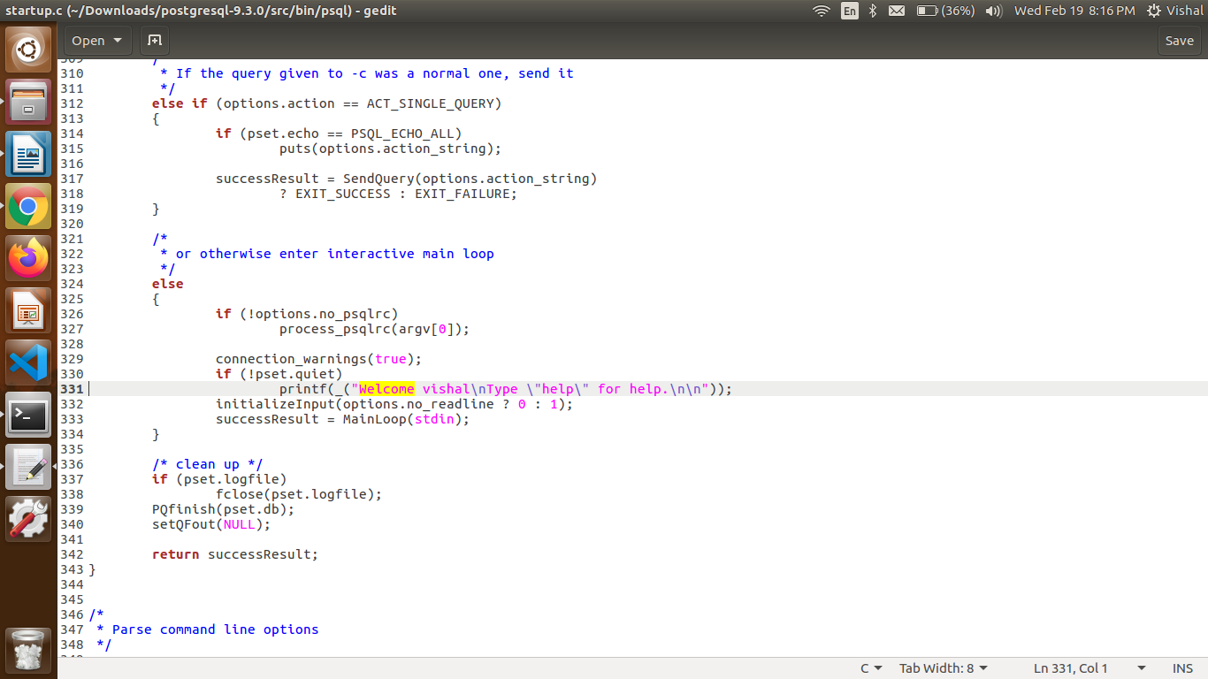
reinstall postgres to reflect changes.

